Assignment 3
Sumedh Bagade

Deploy index file from 3 different repos on httpd

Steps:
- Login to EC2 instance. This will be our jenkins master
- Install Java 17, apache tomcat 10 and git.
- Configure jenkins by downloading latest jenkins.war file and placing it in apache tomcat home/webapps
- Start apache tomcat 10 by running ./startup.sh in /bin of apache home
- Access Jenkins dashboard using public ip of your instance and configure user account.
- On our github we have 3 remote repositories named jenkins1, jenkins2 and jenkins3. These are all private repositories containing two branches each. Master and quarterly release branch. 2026Q1 is in jenkins1, 2026Q2 is in jenkins2 and 2026Q3 is in jenkins3. These branches have our required index file. To clone this to our master we first need to setup credentials in our jenkins dashboard.

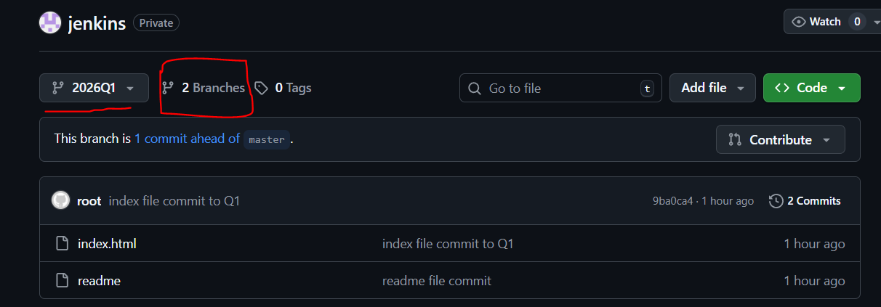

- Go to manage jenkins > security > credentials and create new credentials to access github through git plugin. Here we mention our github username and token.
- Now we have to create 3 different jobs for deploying three index files.
- job1Q1 is for jenkins1 repo. In source code management select git plugin and copy the URL of our remote repo. Select the credentials we created earlier. As our index file is in 2026Q1 branch we mention this name in branch specifier so that this branch is cloned in workspace of our jenkins master.
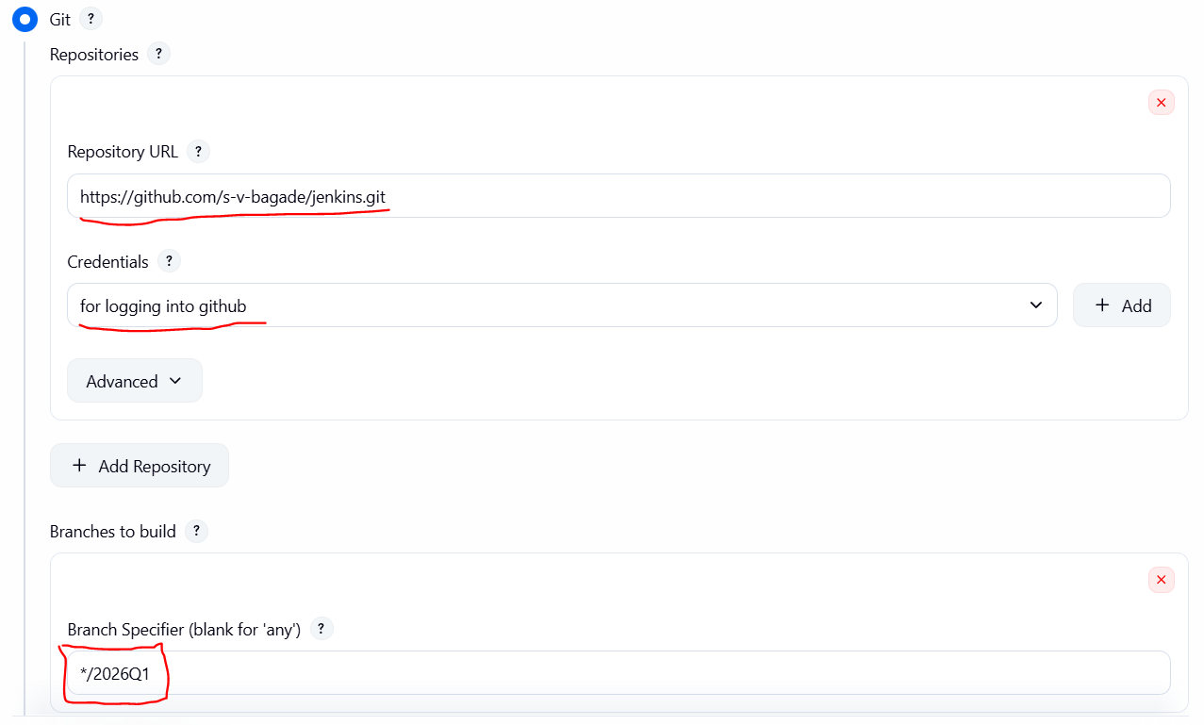

- We also enable “delete workspace before build starts” option so that when we run consequent jobs the data created due to previous job is deleted.
- In Build steps add shell script to configure apache httpd and copy index file to /var/www/html we have to keep in mind that index file from earlier job is replaced with new file so we run cp command to forcefully copy index.html. Repeat steps 9-11 to create jobs for remaining two repos. Scripts for each job is as follows.

job1Q1:
yum install httpd -y
systemctl start httpd
cd /var/www/html
/bin/cp --force /root/.jenkins/workspace/job1Q1/index.html .
chmod 777 index.html
systemctl restart httpd

job2Q2:
yum install httpd -y
systemctl start httpd
cd /var/www/html
/bin/cp --force /root/.jenkins/workspace/job2Q2/index.html .
chmod 777 index.html
systemctl restart httpd

job3Q3:
yum install httpd -y
systemctl start httpd
cd /var/www/html
/bin/cp --force /root/.jenkins/workspace/job3Q3/index.html .
chmod 777 index.html
systemctl restart httpd

- Run jobs one after another and create build. If successful access the webpage using http://instance public ip:80

Results:
- job1Q1
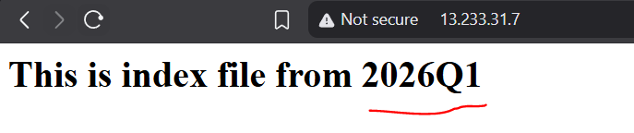

- job2Q2
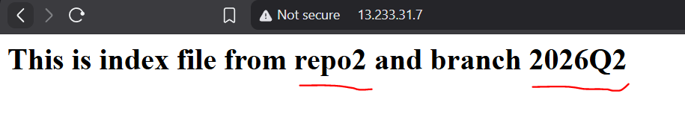

- job3Q3
